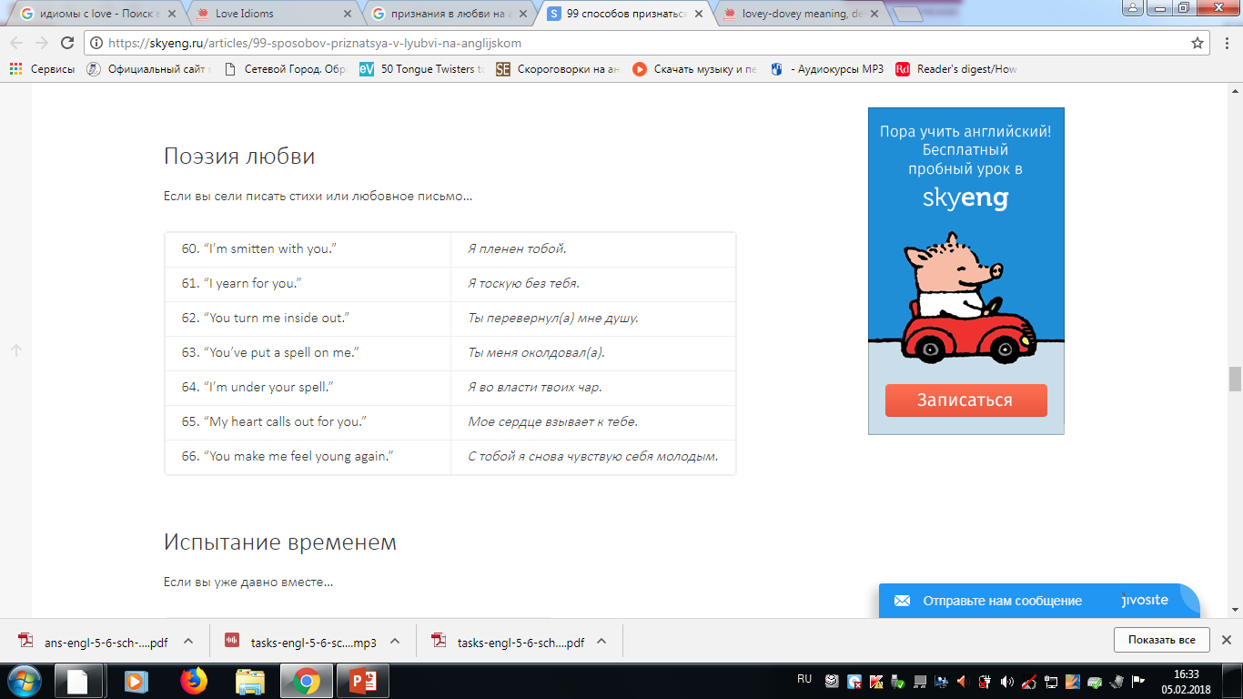Literary style

**Thee = you**

**ideal grace = perfect mercy, kindness**

**I love thee freely**

**with the passion = with all your heart**

**I love thee with a love**

Informal style

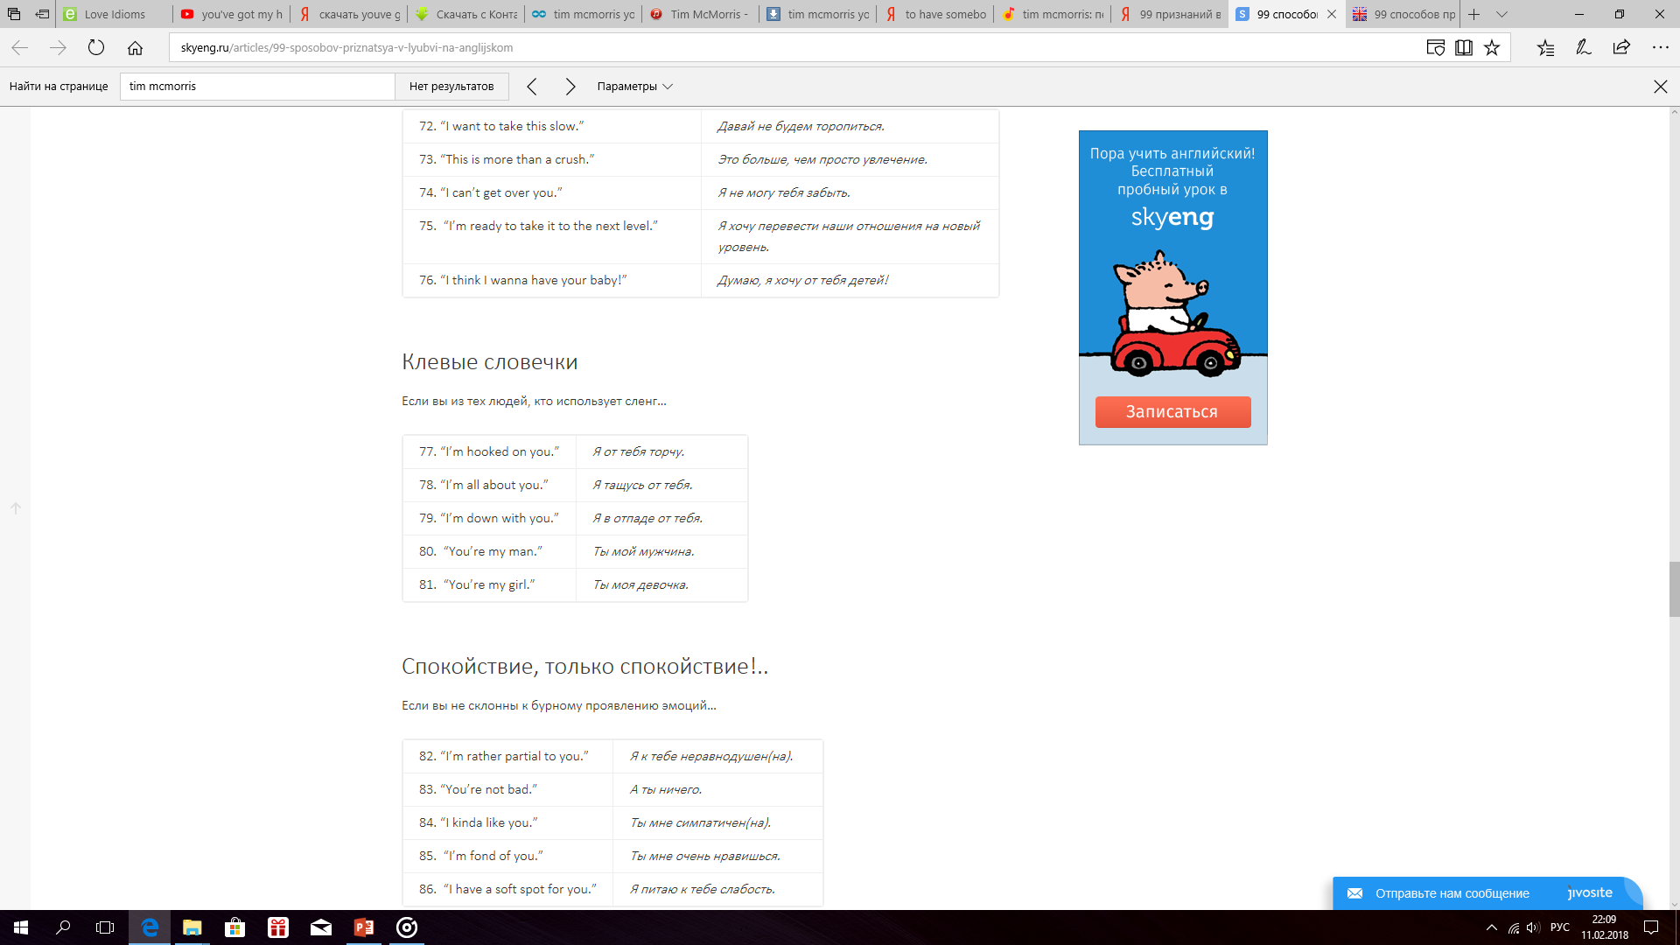

**To be on a adventure for two**

**as long as it’s beside you =**

**If I’m close to you**

**fall in love madly = to love very much**

**The only one I think of**

**You got my heart = took my heart**

**To part = to split up, to break up**